Main Data:

1. Gender Data Portal From the World Bank:<https://genderdata.worldbank.org/>

Datasets:

1. [Parental Leave Policies DataShi Long Zhuang · Updated 6 months ago Usability 10.0 · 1 File (CSV) · 22 kB](https://www.kaggle.com/datasets/shilongzhuang/things-we-do-for-family-some-bald-guy)

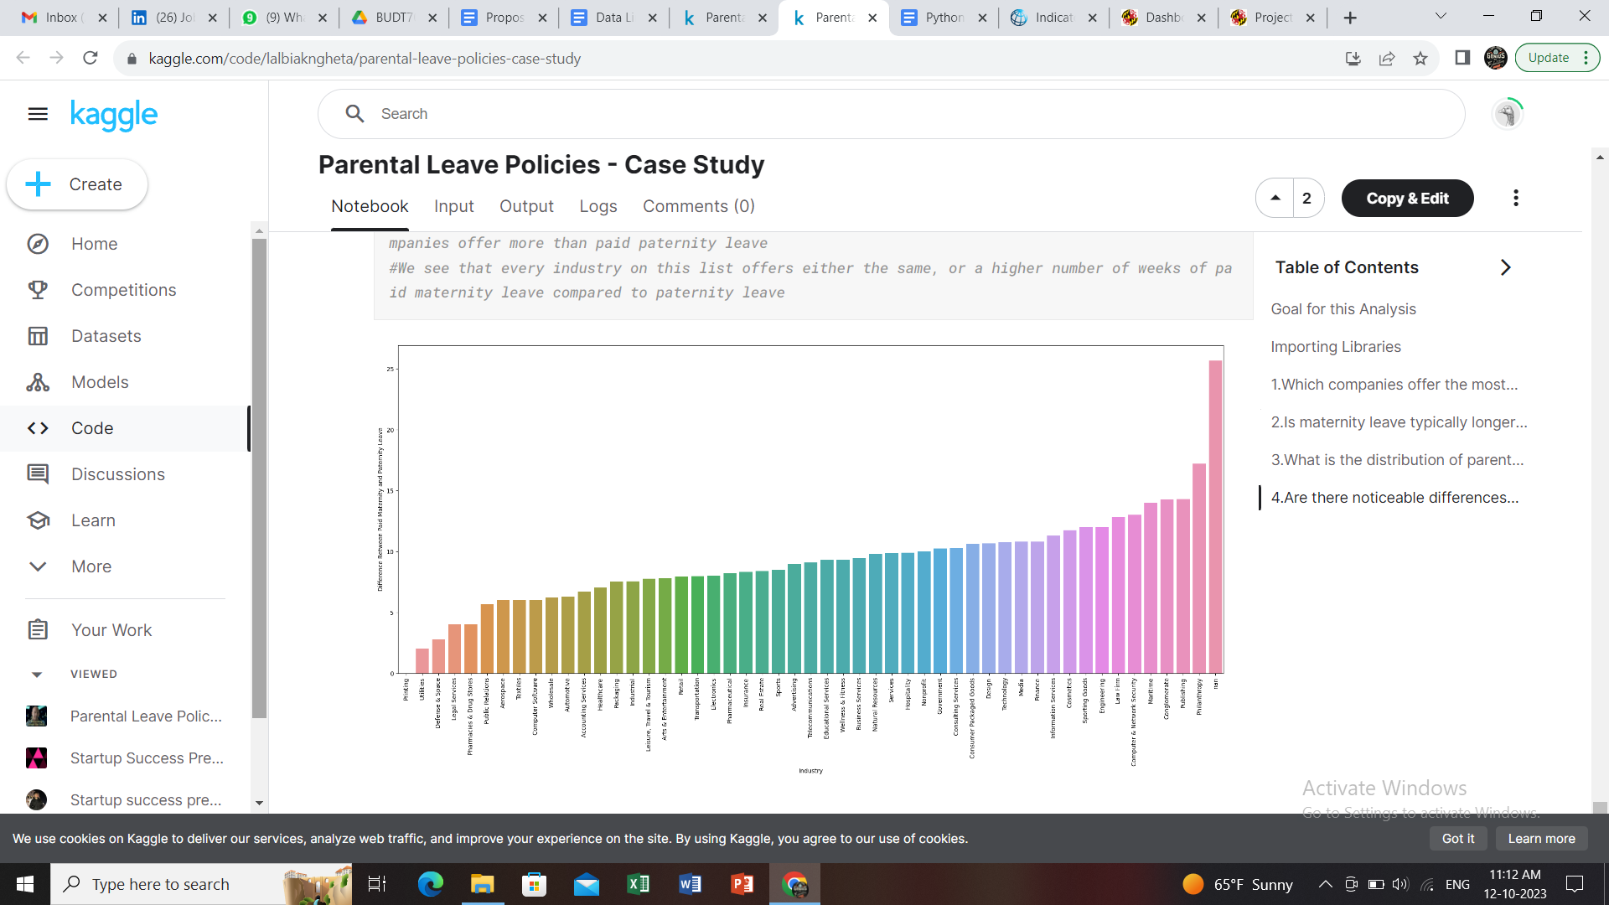

Misc Resources:

1. <https://www.market-inspector.co.uk/blog/2016/08/10-countries-and-their-work-etiquette>
2. <https://viventium.com/workplace-culture-around-the-world/>

Extra Datasets:

1. [Where is time spent by the people around the worldShubham Trivedi · Updated a year ago Usability 10.0 · 2 Files (other, CSV) · 26 kB](https://www.kaggle.com/datasets/shubhamptrivedi/where-is-time-spent-by-the-people-around-the-world)
2. [Healthy Lifestyle Cities Report 2021Prasert Kanawattanachai · Updated 2 years ago Usability 10.0 · 1 File (CSV) · 2 kB](https://www.kaggle.com/datasets/prasertk/healthy-lifestyle-cities-report-2021)
3. [Life Expectancy (WHO)KumarRajarshi · Updated 6 years ago Usability 8.2 · 1 File (CSV) · 121 kB](https://www.kaggle.com/datasets/kumarajarshi/life-expectancy-who)
4. <https://www.cdc.gov/nchs/products/databriefs/db388.htm>
5. <https://genderdata.worldbank.org/data-stories/flfp-data-story/>